Unit 5 and 6 REVIEW – STUDY!!

Universal Gravitation:

Equations (2):

Variables (Units)

F

Ac

G

R

M1

M2

V

The diagram below represents Neptune, Uranus, and the Sun in a straight line. The center of mass of Neptune is 1.63 X 1012 meters from the center of mass of Uranus. Calculate the magnitude of the interplanetary force of attraction between Uranus and Neptune. (The mass of Uranus is 8.73 X 1025 kg and the mass of Neptune is 1.03 X 1026 kg)

Example: An object weighs 100 Newtons on Earth’s surface. When it is moved to a distance that is one Earth radius above Earth’s surface, it will weigh-

Inverse Square law:

What is the direction of the force(s) that maintain(s) circular motion?

Fundamental Forces

Strong Nuclear

Weak Nuclear

Gravitational

Electromagnetic



A stone stuck on the edge of the tire of a unicycle wheel with a radius of 0.25 m has a centripetal acceleration of 4.0 m/s2. What would the speed of the rock be immediately after it falls off the tire?

An astronaut weighs 8.00 × 102 Newtons on the surface of Earth. What is the weight of the astronaut at a distance of 6.37 × 106 meters above the surface of Earth? (radius of Earth = 6.37 x 106 meters)

Label Conduction, Convection and Radiation

MATHCING:

1. Heat transfer by moving fluids A. Conduction
2. Heat transfer by direct contact B. Specific Heat
3. Heat transferred by waves C. Convection
4. A measure of Kinetic Energy D. Radiation
5. Heat required to increase 1g of water by 1 C E. Temperature
6. The universe tends to disorder F. Entropy

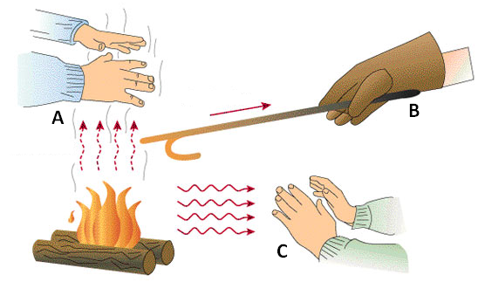

LAWS Of Thermodynamics

1st Law of Thermo –

2nd Law of Thermo –

3rd Law of Thermo –

Label Each Statement as an Example as Conduction (C), Convection (V), and Radiation (R)

1. Hot coffee is stirred with a spoon. The spoon gets hot due to--
2. Near the ceiling of a room the air is warmer. The warm air rises because of--
3. A blacksmith using a bucket of water to immediately cool off a piece of metal he has been working on is an example of-
4. The transfer of heat by the movement of air currents in Earth’s atmosphere is an example of--
5. A man who was sleeping wakes up because he hears the smoke alarm go off in his house. Before opening the bedroom door, the man feels the door to see whether it is warm. He is assuming that heat would be transferred through the door by —
6. The moon’s surface becomes hot during the long lunar day because the sun transfers heat to the moon. This heat transfer is accomplished almost entirely through the process of —
7. The primary way liquids and gases transmit heat is by the process of —
8. A college student holds the back of his hand near an iron to see if it is hot. Heat is transferred to his hand by--

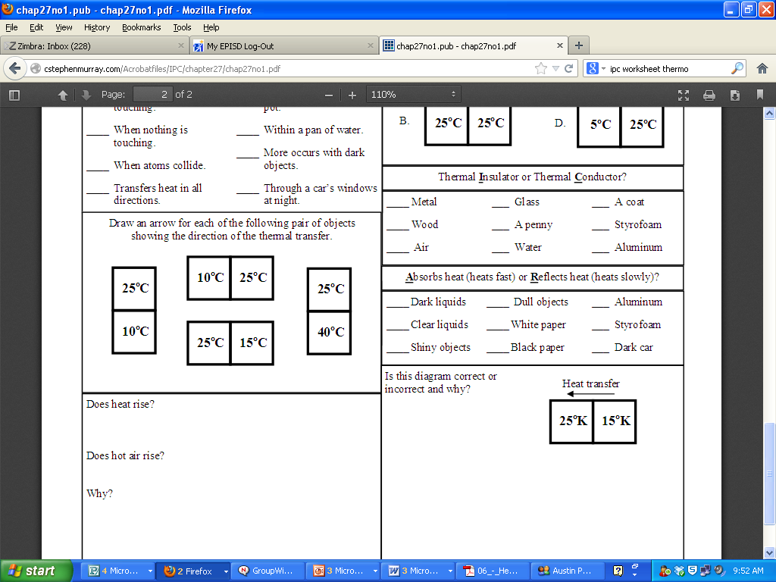

Conductor:

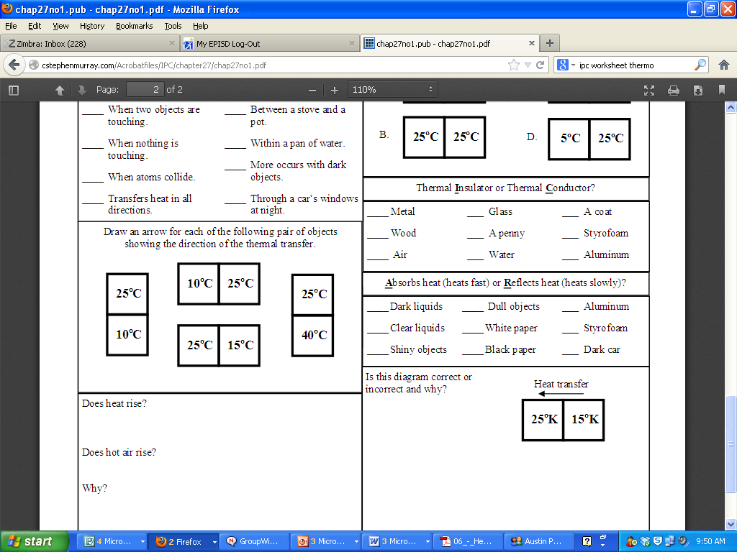

Insulator:

If two small beakers of water, one at 70°C and one at 80°C, are emptied into a

large beaker, what is the final temperature of the water?

An egg cooking in a frying pan is an example of what type of heat transfer?

The heat energy produced from a fireplace that warms up a room is an example

of what type of heat transfer?

A substance that heats up relatively quickly has a –

High specific heat?

Low specific heat?

High density?

Low density?